Update #7
Thursday night 12/22 - Christmas is creeping up quickly. It will be here and gone before we know it.
Since we last visited, I spent a week in Port Louis, Mauritius followed by another week in Djibouti. Finally got to spend a few weeks here at home. Sometime in January, I may be going to Kigali again. There is a Technical Security Upgrade that I will be there for the kick off. I helped with the survey of it last year and will be the Government Technical Monitor for it.
I sat watching TV with the Pretty Lady tonight and they gave the temperatures at several places in the world. One of them was Bagram Airbase in Afghanistan. Brought back some memories, as five years ago about now, I was in Bagram waiting to fly out of the Afghan Theater for the last time. I remember attending Christmas Eve Mass in the huge clamshell tent with the Wilms heaters roaring away. Big heaters that used jet fuel. No way could I imagine being in Ethiopia five years later. I look forward to finding out where we will be in five more years.
One of the many things I like about being here in Addis, is the weather is like Spring every day. After growing up in the Texas Panhandle, where the elevation is about 3400 feet and flat as a desert, the wind always seem to blow and the temps were anywhere from below zero to the upper 100’s. The smell was either dust or some feedlot in the next county. But here… Sometimes I step out of the Embassy to do some work outside, and have to stop and smell the fresh mountain air. Near the street, it’s different. My alarm goes off at 5:30 every morning. I get up and open the door to the third floor balcony. Make coffee and my oatmeal, check email, then get in the shower. Before I do, I will open the window in the bathroom to get a slow cool breeze moving through. I keep the lights off, and take a long shower. By the time I get out, there is sunlight coming in. Very peaceful. The only time that will change, is during the rainy season. Other than that, the sun comes up every day between 6 and 6:30 whether you want it to or not.
We have yet to check out the many restaurants that we hear about, and after the holidays we will venture out more, now especially since we have our truck. We have some incredibly dear friends in Virginia who think this is a rough life and they actually thank us for doing it. I tried to tell them, it’s quite comfortable and definitely enjoyable. There are some tradeoffs, but overall, the positive list far outweighs the negatives.
I’ve been driving to work about 2 weeks now, and it’s is still a cautious and sometimes harrowing experience. I have learned not to make eye contact with other drivers. In the States, it’s the opposite; but here, eye contact gives the other driver the right of way. So, the trick is to watch them out of the corner of my eyes, and keep moving. One of the hazards of the roadway is missing manhole covers. When the streets were first built by the Chinese, some of the covers were stolen to sell for scrap metal, and they have not been replaced. Most of them have been kindly painted around with white paint. Another interesting thing, most locals drive with their lights off at night to conserve their battery and save fuel. It’s absurd to us, and there is no convincing them they are wrong. Some will at least use their parking lights.
My drive in the morning is 5 miles and takes about 20 minutes. By leaving about 6:45, I miss much of the traffic. On the way home, it’s crowded and slow moving at times. Takes about 30-35 minutes. When Pop passed away several years ago, Mother Dear had me go through his shop and clean it up. I found an old altimeter for a car, which is the type of stuff he would collect. I mounted it in our truck, and it’s really quite accurate. Here at home, it shows about 7550 feet above sea level. On my way to work, it’s a steady uphill climb. By the time I get to the Embassy, the altimeter reads about 8050. So, between our house and the Embassy, it’s about 500 feet! When I go home, I seldom have to use the accelerator. Horn and brakes, yes. Accelerator, No.
The biggest obstacles along the roads are the pedestrians and the blue donkeys. (taxi vans) Half my drive in the morning is very little traffic, but the other half, closest to the Embassy, has a great deal of people walking to the taxi stands to catch a taxi or bus. Because of the uphill climb toward the Embassy, there is a great deal of smoke and fumes from the vehicles, Diesel engines outnumber gasoline engines, and I don’t think any of the locals know how to tune an engine. I have to close my windows and turn off the ventilation inside the truck to keep from breathing the stuff. Once I get to the Embassy, it is at the top of a hill and away from the fumes and the clean air returns.
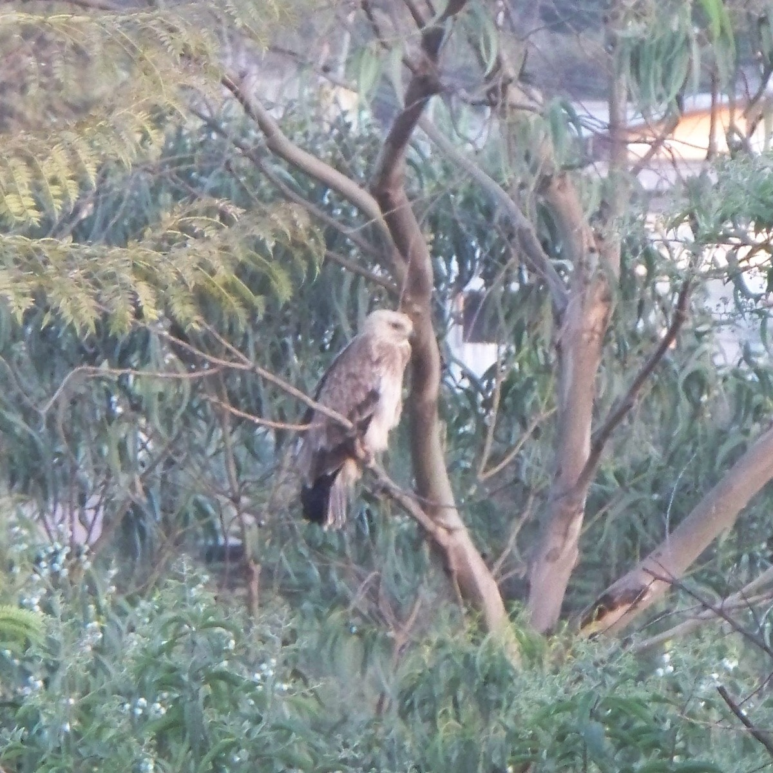
Yesterday evening, Terese and I sat out on the third floor balcony watching the daylight slip away. I glanced out and saw an owl land in a tree not far away. Took a butt-load of pictures of it. Amazing thing to see at sunset. Last Saturday and Sunday mornings, a few monkeys showed up. When we first encountered them months ago, we had fun feeding them and watching their acrobats. Even though their antics were destroying our backyard, it was still something to see. Now the animals are not wanted. Just a few won’t do any harm, but if they find something to eat, the whole troupe will arrive. We have several rose bushes they will eat. So, when they show up, it’s battle time. I found the best deterrent, is the water hose. But they have learned to climb higher in the tree than my water hose will squirt. I do have a sling-shot coming that I will use with rock salt. Won’t hurt them, but should drive them away. If Pop was here, he could give me some pointers as he had to deal with raccoons getting to his bird feeders. … come to think of it, he wasn’t too successful with them either.
Terese, being the gracious hostess and diplomat, invited Michael, our gardener and day guard and his family to Christmas dinner. He excitedly accepted. He will bring his mother and stepdad and maybe a brother. Unfortunately, he will not be bringing his grandparents who he lives with, because his grandfather is 84 and there are too many steps in the house for him, Especially since the bathrooms are upstairs. His grandmother will not come without him, understandably so. We will send much food back with Michael. I would have loved to meet them and interact with them. The Ethiopians eat quite differently than us. For one thing, they don’t use utensils to eat. They have a flat gray bread that seems to have a foam texture to it and a slight citrus taste to me. This “injera” is what they use to pick up food to eat, with their right hand. http://en.wikipedia.org/wiki/Injera I have seen groups of locals in the Embassy dining area with one large tray of food, and several rolls of injera and they all share the meal. Sometimes I will see one of them eating spaghetti with their hands.
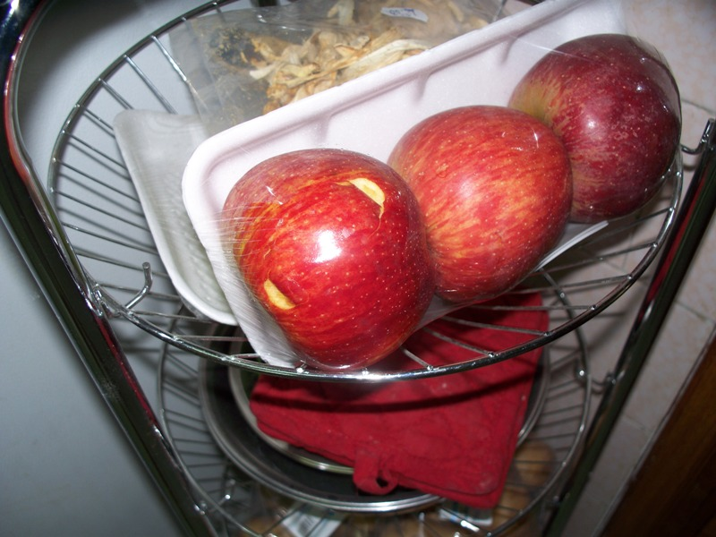
Christmas Eve: We have been getting the house in order to have Michael and his parents come tomorrow, but we also invited Shawn, the gardener from next door, and his wife and new little one. It will be an experience. So, I’ve been going around the house putting things away and finding places for things that don’t have a place yet. While I was upstairs, I heard Terese yell at the cat. I stumbled downstairs to see what the commotion was, and I caught a glimpse of a monkey leaving our second floor balcony. Terese said, “Look what that damn cat did, she knocked over the trashcan.” I said, “Huh, no, the cat is still in the yard watching the birds. That was a monkey!” A monkey came in from the balcony and went into the kitchen and jumped up on the trashcan to get at some fruit. It tried to take a bite out of an apple, (still wrapped in plastic) before knocking the trashcan over it was standing on. This took place behind her back as she did dishes at the sink just 4 feet away, and never saw the brazen little bastard. She just thought it was the damn cat who was still outside and totally oblivious to the monkey escaping along the top of the fence above her as she sat among the flowers.
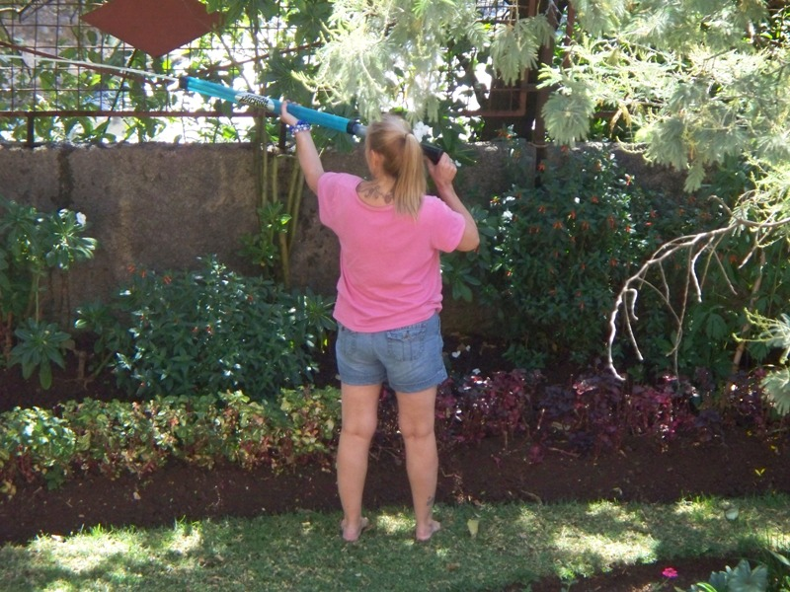
Well, this changes things with the monkeys. It turns out that Michael has been using a power squirter to get to them, so this morning when they showed up, we used it on them. See the picture of Terese using it .
We shall see what happens when I get the sling shot. Maybe forgo the rock salt and go straight to using buckshot. We only have three roses right now, and we want them to last.
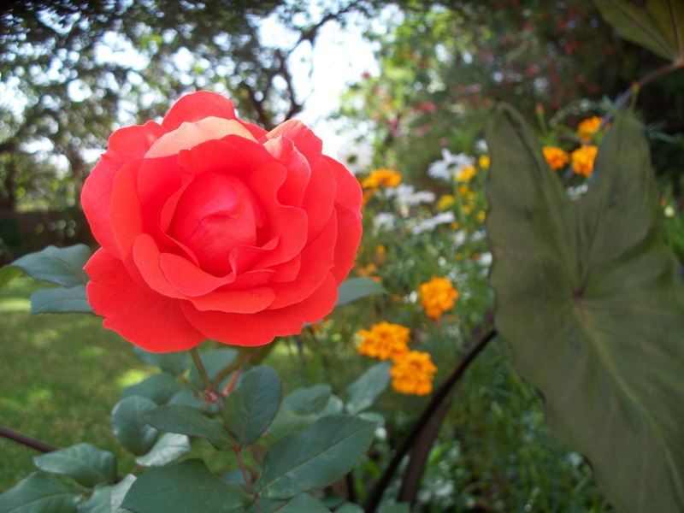
Tomorrow is Christmas Day for us. The Ethiopians will celebrate it in two weeks. Our guards know and understand it’s our Holy Day, so they have brought us gifts. Talahun gave us a bag of Ethiopian coffee, which we are very pleased with. Eshestu gave us something, but we haven’t opened it yet. We will tomorrow. We gave each of them a card with a monetary bonus in it. We gave Michael a DVD of American cowboys. He as well as many people here are fascinated with our western history. Some still think cowboys ride the streets on horses with their cowboy hats and carrying side arms. Michael knows that’s not the case anymore, but he’s still fascinated with it. The DVD covers our western history up to the modern day cowboy.
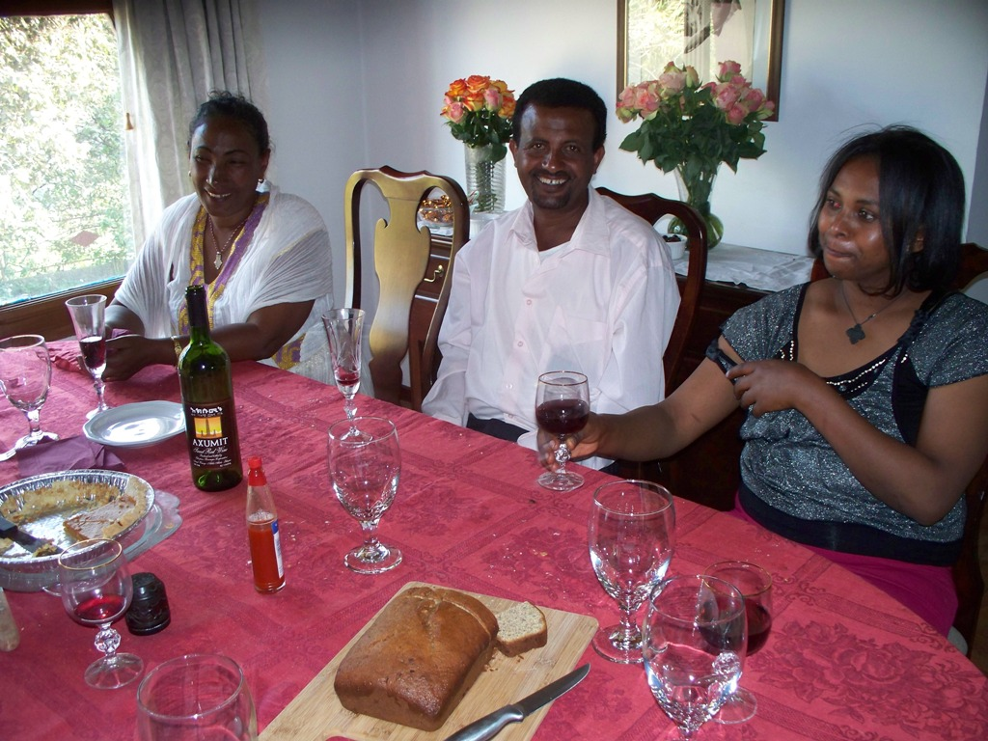
Monday, the day after Christmas: The dinner went very well. The two families are very nice and very appreciative of Terese’s invite. Turns out this is one of the fasting periods in the Ethiopian Orthodox Christian Church. The month before Christmas, they refrain from eating meat products which also include meat by-products. Basically a vegan diet. No meat, dairy products, eggs, etc. All of them are fasting, but all also broke their fast for the meal except Shawn who is very devout. So, the meal was not lost. For them the traditional Christmas meal is some kind of chicken. So turkey was an interesting meal. This was the first time for them to eat cranberry, pumpkin pie, turkey stuffing, gravy and chocolate chip cookies which they could have by just reaching into a jar. They did drink wine with us and took several helpings of everything. Shawn’s little one is 15 months old and pretty much made a mess of the carpets, but we didn’t mind. We feel good knowing they truly enjoyed the meal. Afterwards, we went outside in back to walk among Michaels’ garden and take pictures. This is a picture of Michael’s mother and stepfather, and Shawn’s wife. Below are more. Shawn’s wife with their chubby little one (Danny). Then Shawn with the chubby little one. Then further down is Terese with Michael’s Mom and then with his family. Needless to say, everyone very much enjoyed the afternoon. Terese did very well inviting them. As many of you know, she is a loving individual. People who meet her are blessed in some way or another. The other day we were at one of the restaurants on the hill, and several other families were there. One family had several kids with them, and it was hard not to be amused by them. One little girl kept smiling at Terese, and when they left, she had to run back to the dining area and give Terese a kiss on the cheek before leaving. A beautiful thing to see!
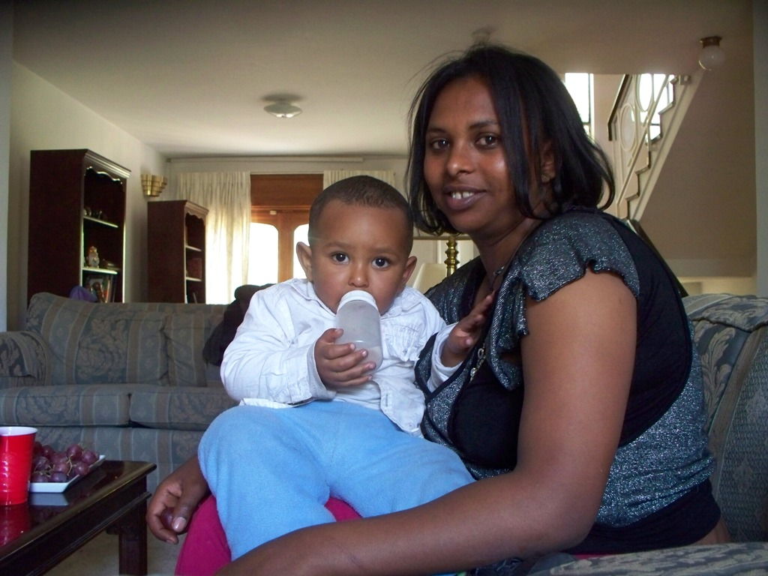
No kiss for me, but I’m grumpy looking.
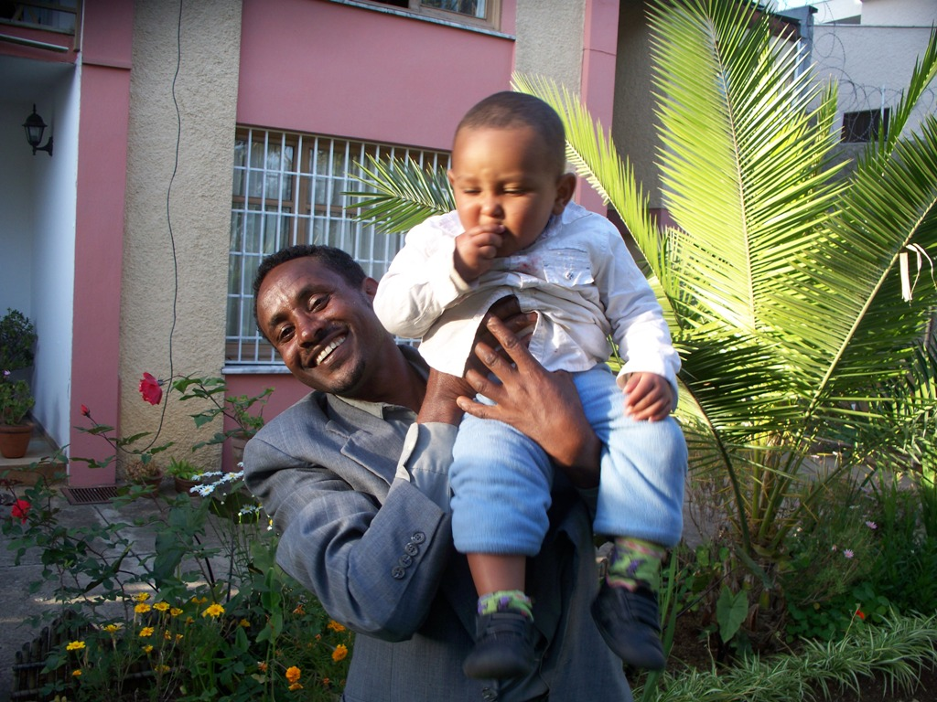
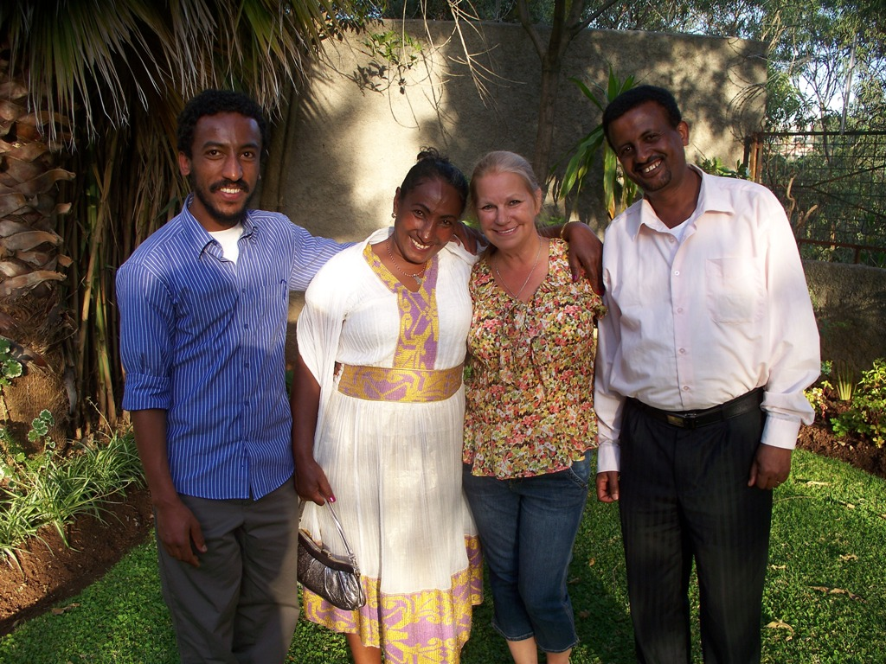
Speaking of restaurants, we found an interesting place we will take guests when they come. It’s call The Rodeo Restaurant and Lounge. It has a Texas theme to it. We sat outside and later in the evening, they lit a fire in a pit nearby. I had a steak which was similar to steaks in this part of the world. As in Moscow, the beef has a slight wild taste to it. No grain fed beef here as it probably came from the pastures of Argentina. But it was good to get steak again and not that expensive. Two steaks, two salads, several beers and drinks came to 440 birr which included a generous tip. That equates to $25. The place was away from the traffic and very comfortable.
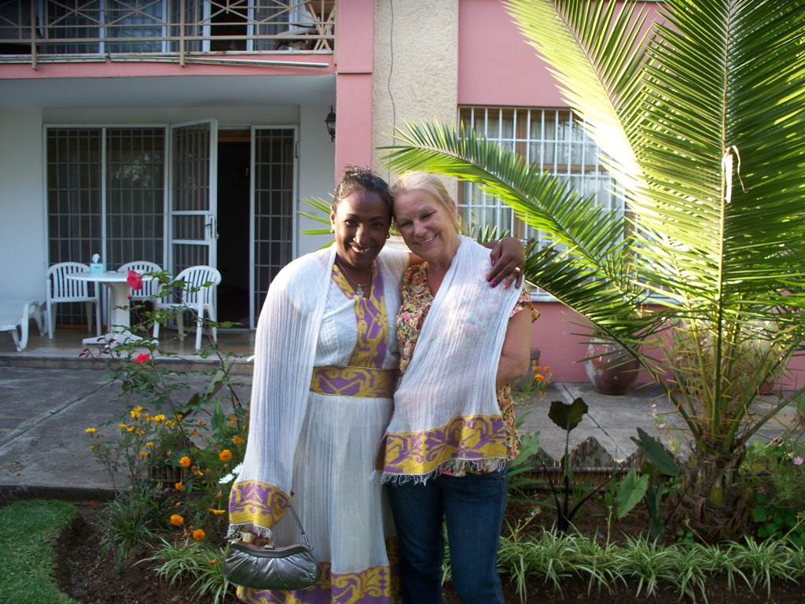
The cost of many things are hard to believe here. Terese picked up what she thought was 3 dozen roses for the Christmas dinner which cost $10.58. When we got home, we realized each ‘dozen’ was actually 18-24 roses.
We opened up Eshestu’s gift to us. He’s one of the night guards. He gave us a beautiful table cloth and napkins. I’ll add a picture of it down below. The napkins come straight off the loom and we have to cut them apart before using. When Michael and his parents came, they gave us beautiful African statues of a man and a woman. Again, look below. Shawn and his wife gave us a beautiful scarf. Perhaps it seems silly to show everyone our gifts, but we were not expecting such beautiful gifts from them, and I hope you don’t mind us showing them off.
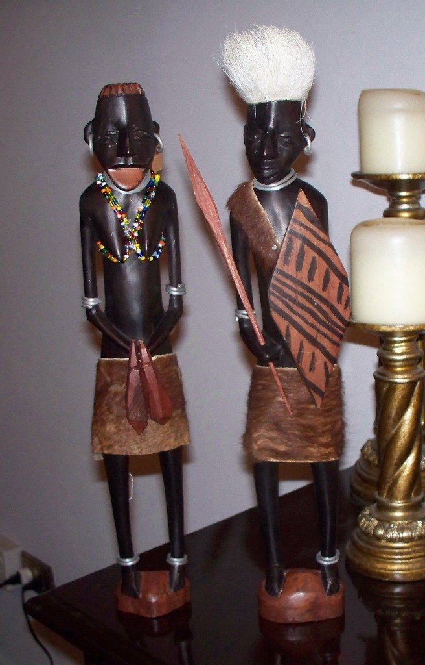
Also, several years ago, my son, Jeremy gave me a train set. I finally got to set it up around the tree and am most proud of it, so I included it below also.
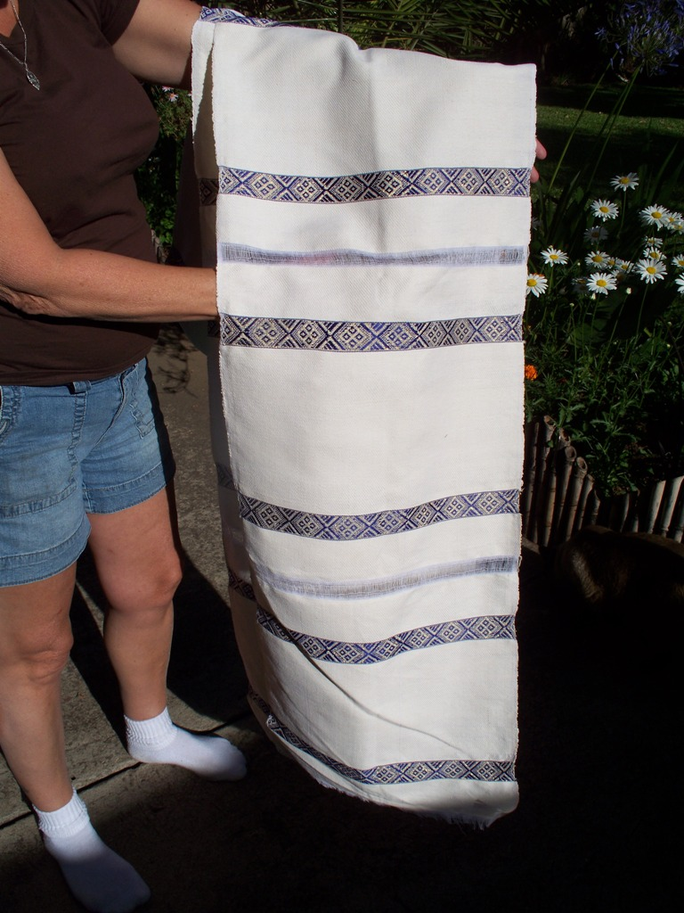
Napkins, still needing to be cut. There is a matching table cloth with it.

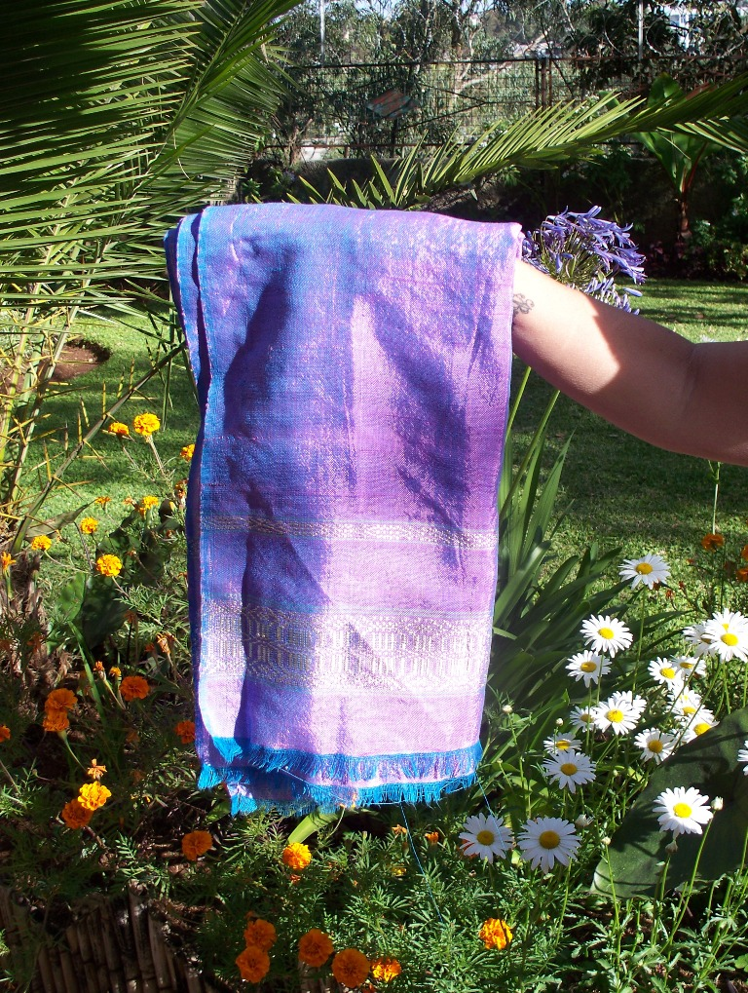
Last Friday, Terese received some good news. A job she applied for was awarded to her. It’s a part time job working in the Consular Section doing what she was doing in Moscow. This is the type of work most people find boring and quit shortly after taking it, but Terese finds it fascinating. It is her love of Life that enables her to find satisfaction in pretty much anything she takes on.
Okay. This is good enough for now. I’ll add a picture of the cheap roses just for beauty’s sake. We’ll be back later.
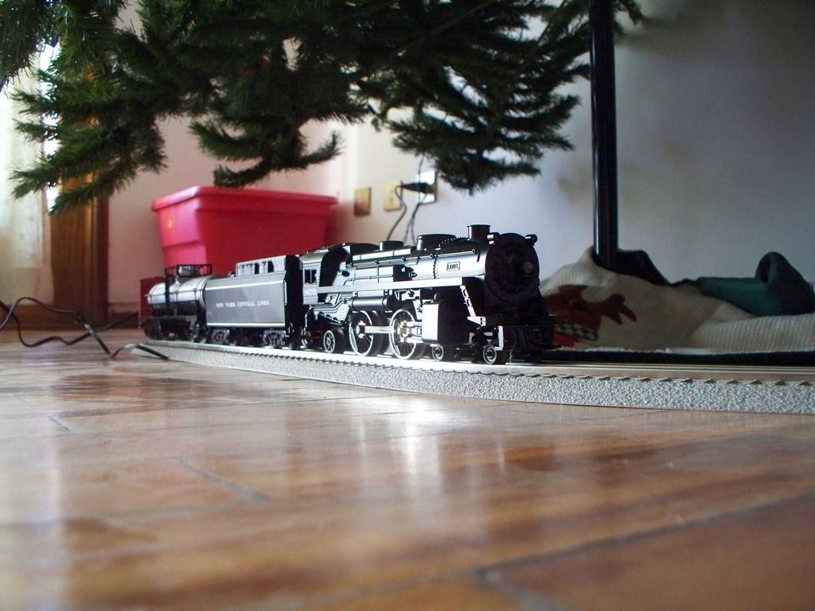
Love D&T.

P.S. From Terese > We are waiting for you (any of you) to come visit. All are welcome & we would love to have you. Please keep in mind that the ‘Rainy Season’ is between Mid June & first of October. Just pick a time & let us know so we can get the paper work rolling. Every day there is an adventure here. Come & let us share with you.
Just sayin’…..
