Update #6
Thanksgiving: It’s been busy the past week. This Sunday, I have to fly to Port Louis, Mauritius to perform some maintenance on some of the equipment. I return home on the following Friday, then that next Sunday, I go back to Djibouti to finish some decommissioning and to help with the Grand Opening of the new Embassy. I am told there will be about 500 dignitaries there. The last time I was there, I met the US Ambassador to Djibouti. She’s a very likable lady. One Friday morning, she invited all the people who were there on temporary duty over to her house for breakfast. She and her husband did most of the work. These are the type of people I enjoy meeting in this job.
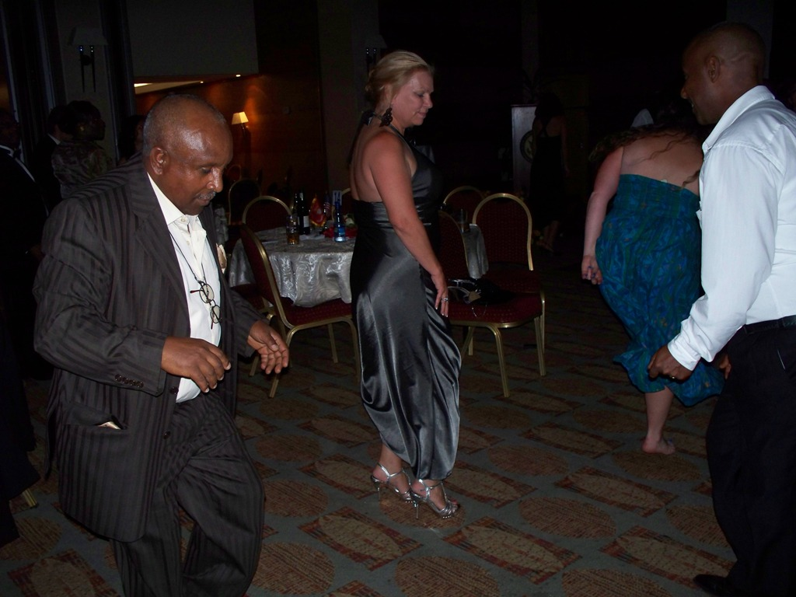
Speaking of good people, we have three RSTs (Regional Security Technicians) working with us. Very nice guys. Each of these Ethiopians has a unique personality. My boss bought tickets to the Marine Ball to those who wanted to come. Two showed up. Ayten and Sirack. Ayten will be 60 in a few years and will retire. Sirack is probably in his early 40’s. They loved to dance, and most often just danced with each other. At one point when Terese decided to kick up her heels, she ended up dancing with both of them at the same time. The other RST, Solomon, is a very religious individual who has very strong morals. He’s sharp and not afraid to confront Life when necessary. The other day, the two of us took a quick trip to the warehouse on the other side of town, (with him driving) and he pretty much let the other drivers know what he thought of them.
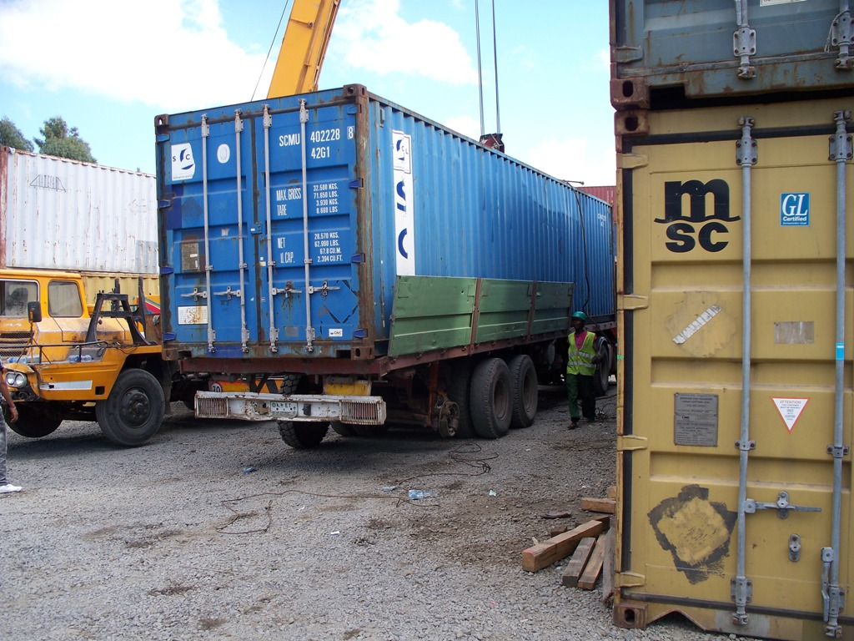
Friday, the 25th: One thing that surprises Americans overseas driving, is the use of the horn. In New York for instance, the horn is used to show contempt. In most countries, the horn is used as a warning or to let pedestrians know you are approaching. Our vehicle has a very subtle horn, which I will use for warning. I also have an air horn I am going to install to use for contempt.

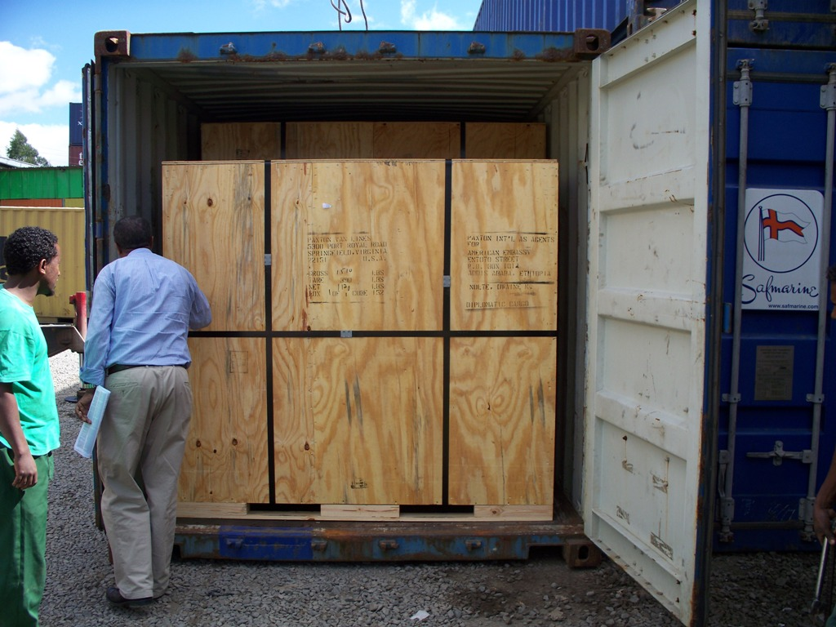
We went and watched our shipment being unloaded off a truck. It was a 40 foot container which had all our household items, our consumable items and our POV. (Personally Owned Vehicle). Later that day, everything arrived at our house except for the POV which has to be inspected and registered. It takes about two weeks, because diplomatic bureaucracy is involved. I hope by the time I return from Djibouti, we will have it. If you look closely in the picture above, you will see that the truck trailer has three axles, but only two wheels on the camera side. They had a shipping strap holding this side of the axle up. As the saying goes: “Welcome to Africa.”

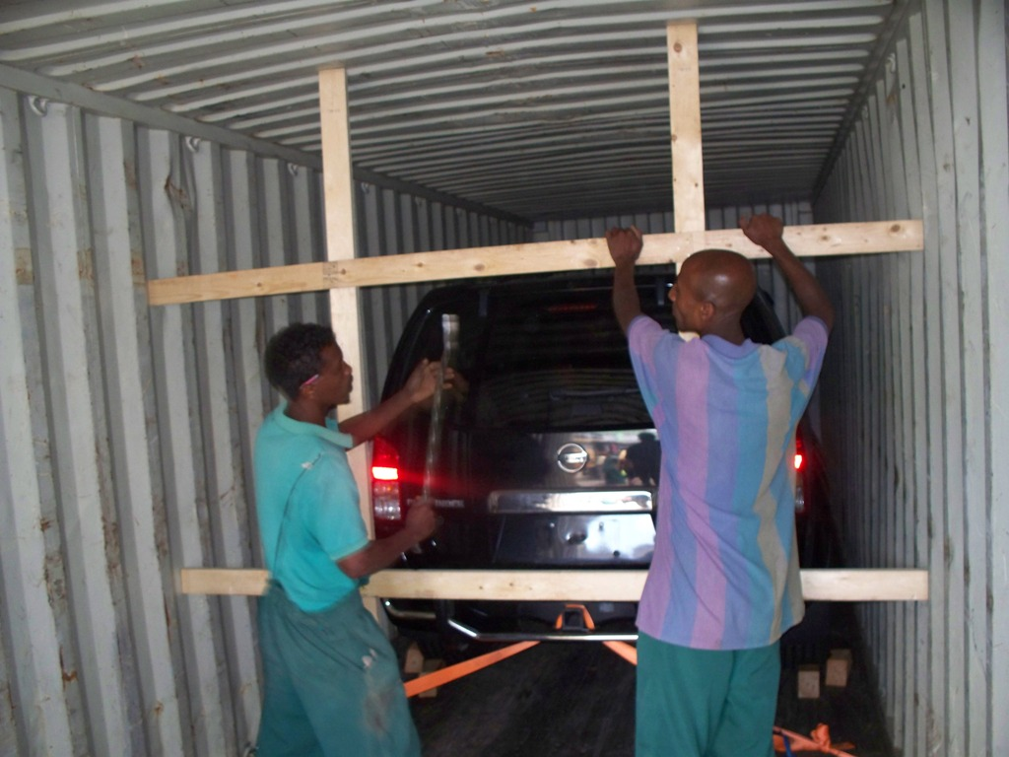
Before we get our driver licenses, (which is actually a courtesy to the Ethiopian Government) we have to attend a driving briefing. They show several videos of accidents and near accidents in Addis, to show us what to expect. Many US Government vehicles overseas, especially those areas with high driving fatalities, have cameras installed near the rear view mirror. It is design to record the images of the driver and the roadway in front if there is a sudden reaction with the car, such as a hard breaking or collision. It records about ten seconds before and after the incident.

The streets in Addis are considered pedestrian walkways by the populace. Even though there are swarms of vehicles on the streets, the people still walk among them as if it is their right. And it actually is. In Addis, pedestrians have the right of way, although the drivers don’t yield. If we do hit one, it will be our fault even if they walk out in front, because #1. We are white, (which means wealth) and #2, We are Ferenj (foreigner – which means wealth). Several videos we saw, in which a pedestrian was hit, most were able to walk away. Many of them will first approached the driver wanting money.
It is truly amazing to watch these people. In the States we are used to seeing people look before walking in traffic. Here they don’t. They will take a step into the street, without looking. It seems they have no sense of self preservation. It is the same with their driving. They pull out in traffic and not look. We have to watch out for them instead, because it will still be our fault.

Saturday, the 26th: Every main street has its share of beggars. Many times while at an intersection, women will come up holding a small child wanting money. They will knock on the windows and press their faces against it and motion they are hungry. It takes awhile to notice the difference between those who are “professional” beggars and those who are truly in need. The women at the windows are comfortably dressed and the children are well fed. Still nothing wrong with giving them money, but as soon as you do, a swarm of beggars will come from nowhere to get their share. Once a month, I have to walk up the hill to the main street and down the road to purchase some Internet tickets. That’s how we get online. On the way, little kids will approach me wanting money. I always carry a handful of 1 Birr notes to hand out. As sure as poverty, once I hand out a Birr note, a swarm of kids come out of the woodwork asking for money. I have to be sure and give them only one, in order to have enough left over for all the others.

The beggars who are truly in need, have ragged, dirty clothes and usually are seated or walking with help; either from a stick for support or another human. Many times, someone who is blind will have help moving along and with begging. Many times on the way to get the Internet tickets, there is an old man who is blind and is always helped by a younger man. I always give him something. Today, as I went to purchase the tickets, I crossed the street at the same time and handed the younger man some money which he quickly handed to the blind. Once while riding to work, I saw a blind man about to cross the street with his stick. I noticed another man stop by, and take his hand to help him cross. He did not appear to be someone he knew. … the Compassion of Life is everywhere.

Every day on the way to work and back home, I see beggars along the street with crutches. Many scoot along the ground, usually with a makeshift crutch. Many people in Addis, the beggars and well as some in the general public, have twisted legs or deformed limbs and joints. It’s sad, but they move around very well. I see many people riding along the street in wheelchairs.

From time to time, I see someone standing on the side of the street peeing. (always a man or boy) They do have their back turned, and for some reason, it just seems natural here. We have a close friend who lived here a few years ago, and she said, if you go out of the city, you may see a naked man walking along. Once she saw a naked man using a public phone on the edge of town.
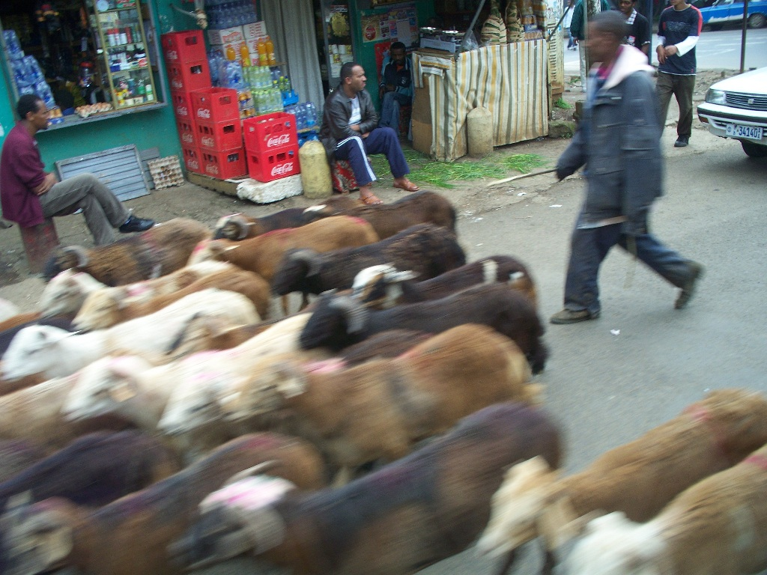
At least once a day, we will see a herd of cattle or goats being prodded along the streets. Usually on the side of the road, but often times, the animals will decide to take up both lanes. All you can do is wait. If we hit one of these animals, (who are usually being herded to slaughter), we have to pay the owner for his dead animal. Except the price will be about 10 times what it’s really worth. Even if the animal runs out in front, it’s still our fault because of #1 & #2 above.

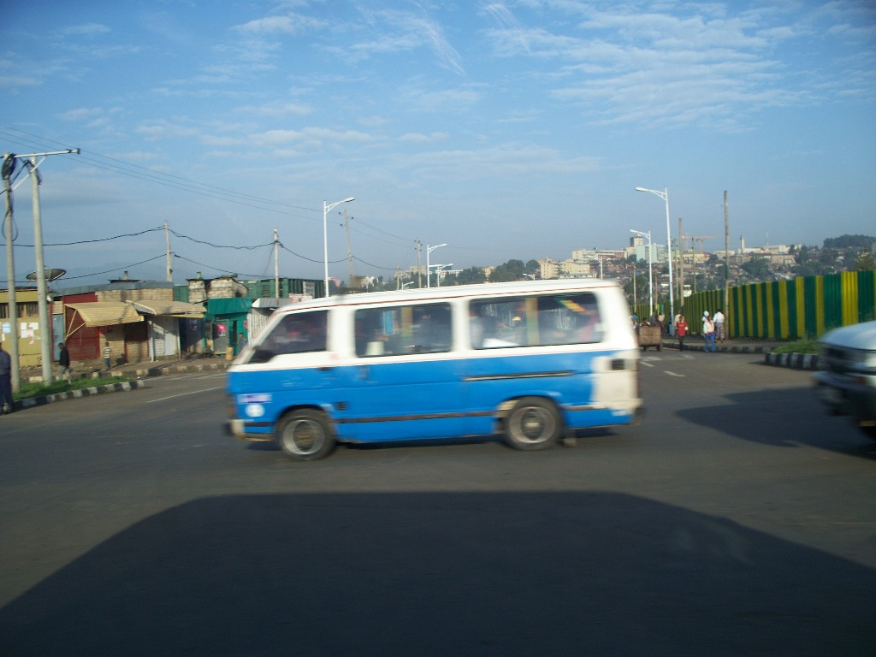
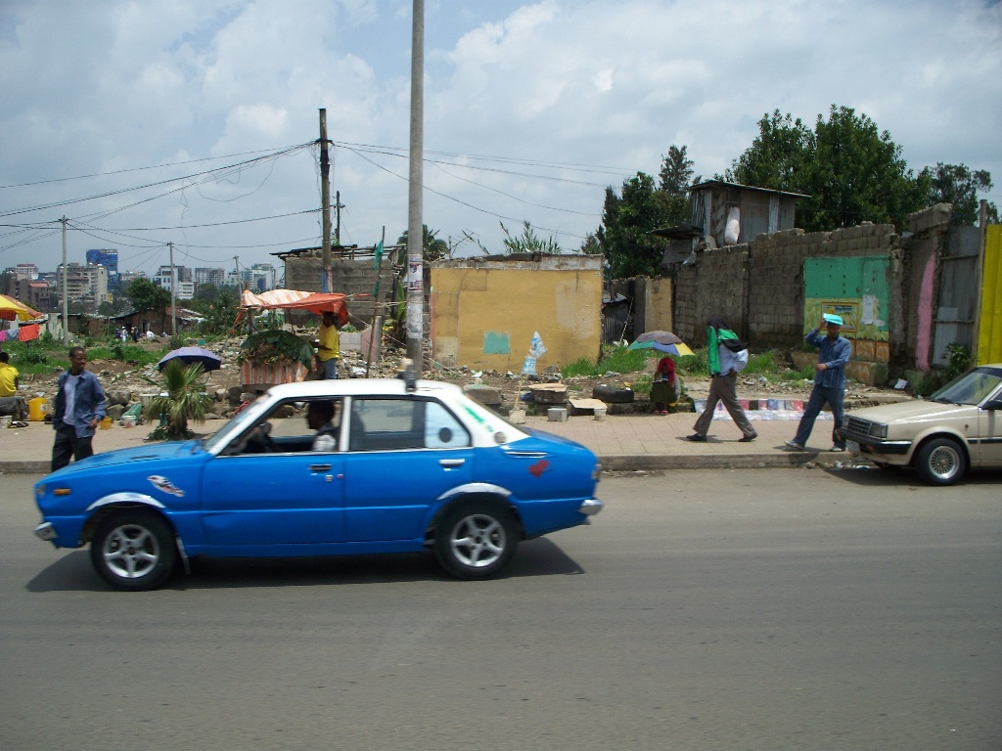
Even with the animals and pedestrians, the biggest hazard on the street are the taxis. All taxis are painted blue and white and are either Toyota minivans or the small Russian Lada. These taxis are called, “blue donkeys”. The British call them, “blue devils”. I think the Brits describe them best. They are so loaded down with passengers, and travel so fast, throughout the year many people die in them. In the mornings and the afternoons, when people travel to and from work, is when the roads are most crowded with pedestrians. They gather at the bus and taxi stops and all run to the next one which drives up. They push and stretch to find a place to sit. There are also large buses that make the rounds. During these times, you can look at the buses and they are so loaded down, that if there is a place to plant one’s feet, there are feet there. People will be sitting on the bus and someone will actually be standing right in front of them, between their knees. I cannot help but think of the smell in these buses.
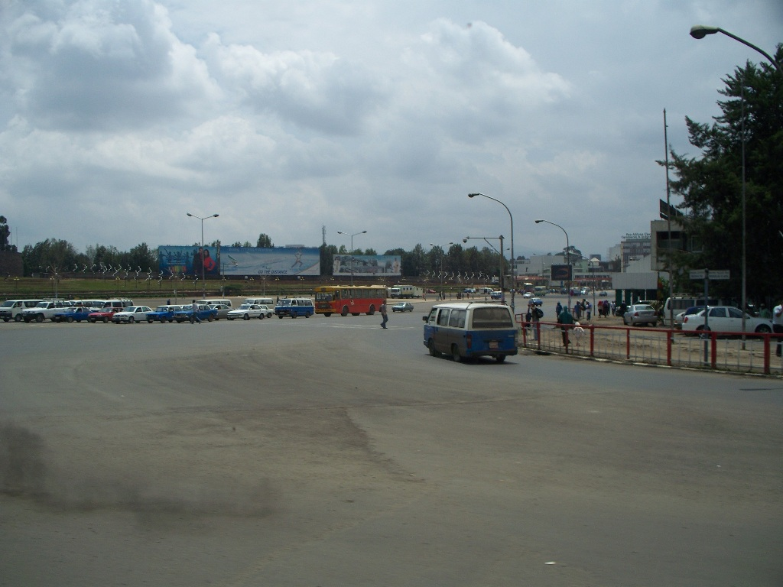
This is not a picture of a parking lot. It is the biggest intersection in Addis. Sometimes its traffic lights work and sometimes there is a traffic cop who stands and watches the hysteria. Either way, it is a curse to have to traverse it.

Below is a picture of a small restaurant at an intersection. There are a great many of these small places. Vendors will also line the streets with their wares, as well as men who have a shoeshine setup. I bet we pass by 10-15 of the shoeshine locations along the way to work. Some people will stop and have their sneakers cleaned.

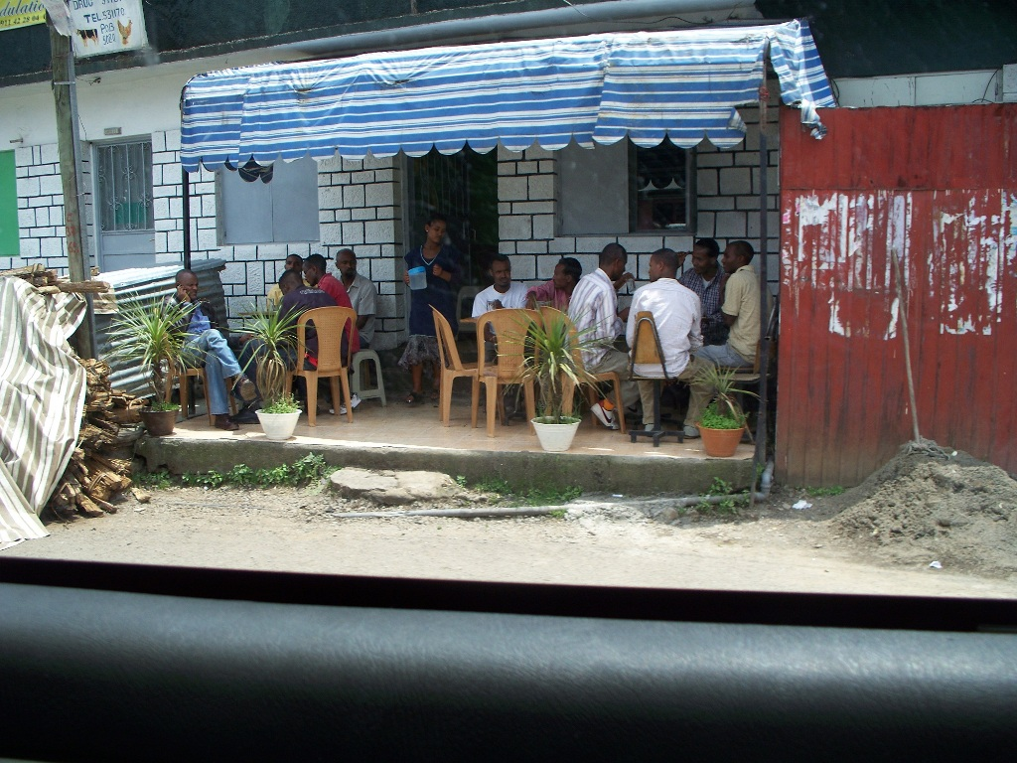
Tomorrow, Sunday, I have to fly to Port Louis, Mauritius for a few days. I’ll try to get some pictures there.

Later, #6, Dad, D, fred, OG
… & the lovely Terese.

