Update #5
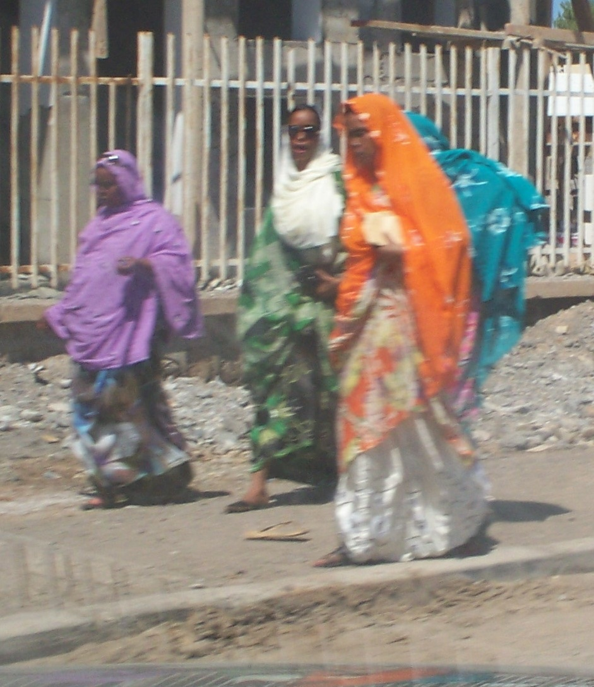
Sat. Nov. 5th : Just back from Djibouti City, Djibouti, which is a small country just east of Ethiopia. It sits on the junction of the Red Sea and the Gulf of Aden. I stayed at the Kempinsky Hotel which is a start contrast to Djibouti City. This small country is heavily Muslim. Most of the men you see on the streets wear “manskirts” to keep cool, and the weather is hot and humid all year. The women wear brightly colored, flowing dresses and head scarves, and some wear the dreaded black burka. The city has a swarm of green taxis that make up at least half the traffic. They all have dents and banged up fenders. One particular vehicle I saw, had a brake light hanging out like an eye hanging out of an eye socket, and yet it was the only light functioning on the rear of the vehicle. The country has a heavy French influence, which explains the French being the dominant language. I noticed any erratic driving will be from a Djiboutian taxi, and any vehicle moving at a high rate of speed will be French.
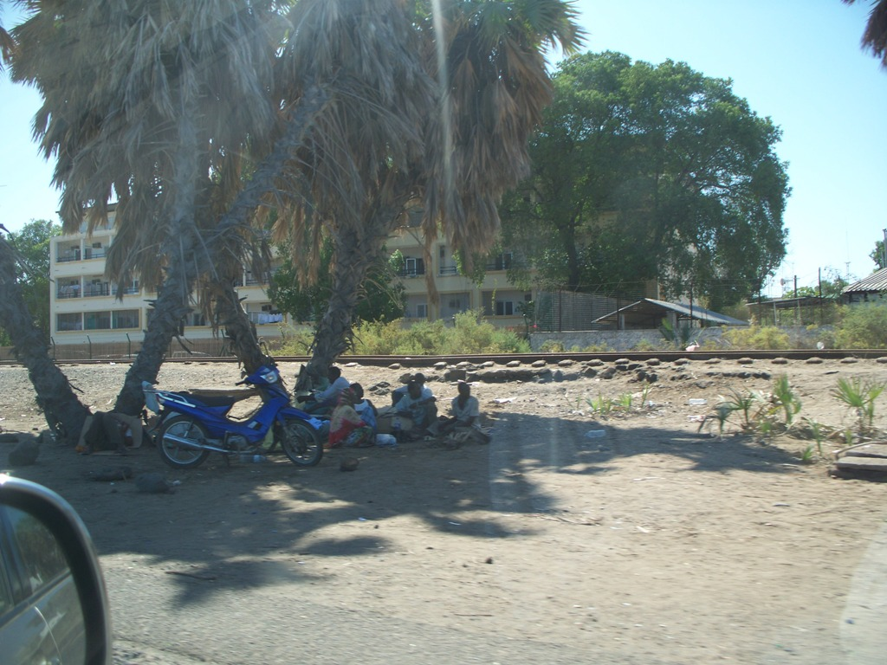
I went there to help commission the new Embassy and de-commission the old one. I was there for just over 3 weeks. Terese came during the final week, and we spent some time by the pool. Every day the temp was mid to upper 90’s with high humidity, so sitting in the pool was nice. In the meantime, the weather back in Addis Ababa was windy and cool. When I got home yesterday, I noticed the forecasted weather for back home in Texas, was 74-38, and Virginia was 58-35. Moscow was 35-17.
When I first arrived in Djibouti, I noticed a parallel with Kandahar, Afghanistan. Aside from the heat, the main irritant are the flies. In the breezes, they are not so bad, but standing in the sun, sweating, they will be there in force. The drive to and from the Embassies run alongside the coast. Every day, as the tide moves in and out, the populace follows suit. During high tide, the locals go swimming and take their baths, as it’s a nice relief from the heat. During the low tide, the mud hardens and dries enough for the kids to play soccer. Any tree along the roadway, will have people sleeping under the shade of it. As the shade moves, so do they.
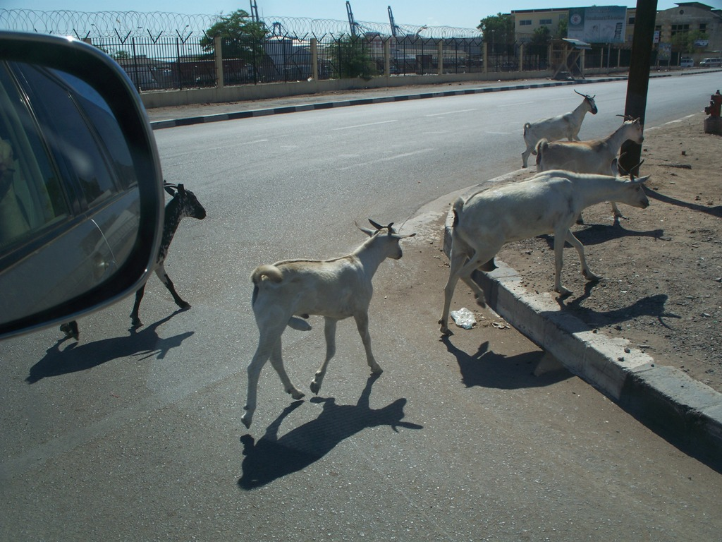
The roads are also shared by goats and camels. During the day, goats will roam freely through the streets with no one herding them. I am told, in the evenings the goats return home. Camels can be seen standing alongside the roads eating the vegetation. No one around watching them.
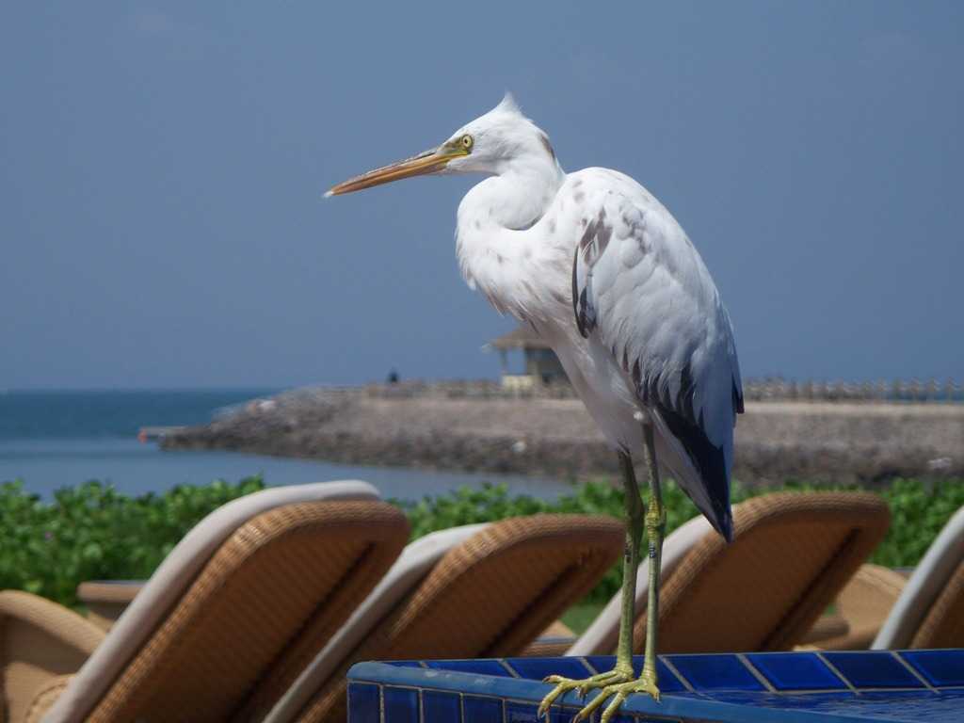
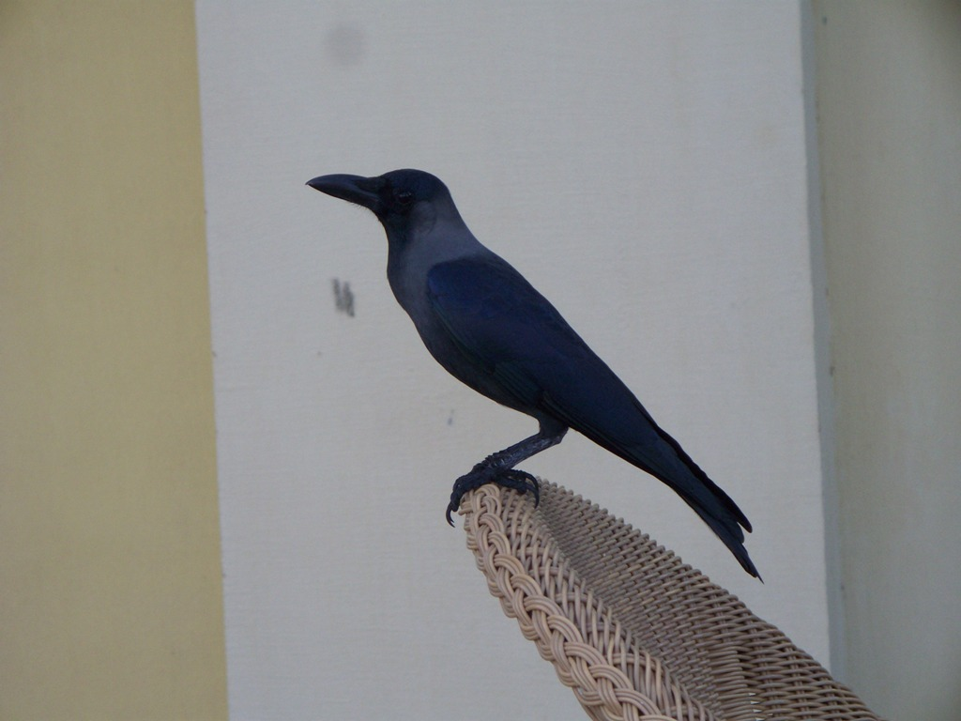
The Hotel has a nice 6th floor “Sky Bar” where we can sit outside and watch the sun set. It’s actually a hookah bar, so it was no problem smoking a cigar inside. I went up there almost every day after work to relax. Even up on the 6th floor terrace, most days had very little wind. The Hotel also has two swimming pools. One is placed under some shade and is very shallow in some places. This is where most of the families went with little ones. The other has a swim up bar. This is where Terese went. Once while there, one of the local inhabitants (see below) sat with her, and even took a dip in the pool with her. Another time, as she sat at one of the outdoor restaurants, another inhabitant sat with her. She seems to attract strange people, and as I write this, it begins to make sense why she’s with me.

We came home to a unexpected heavy rainstorm, which I found to be refreshing. Just hours earlier, we were in the airport in Djibouti, at 93 degrees and 84% humidity, sweating profusely and arguing with the airport authorities about overweight baggage. As I told Terese, it’s nice to be home.
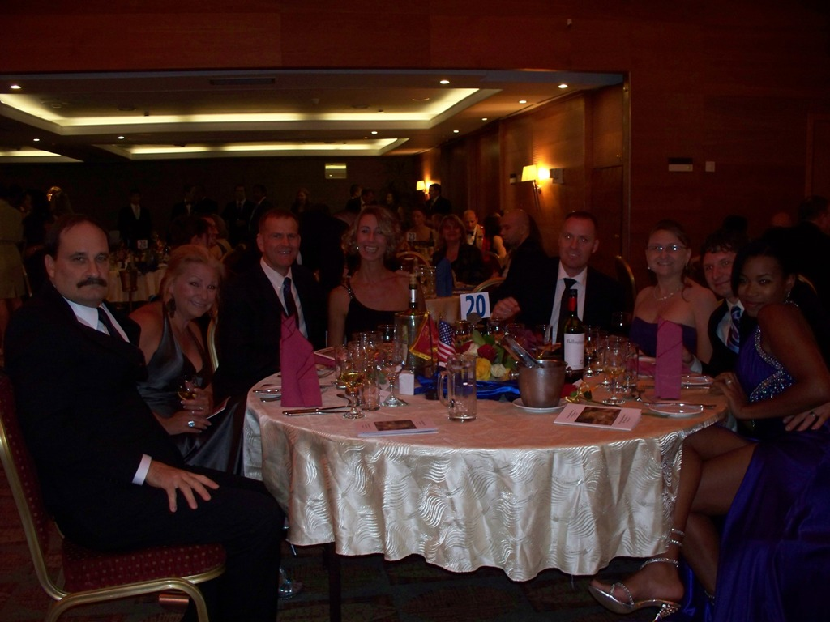
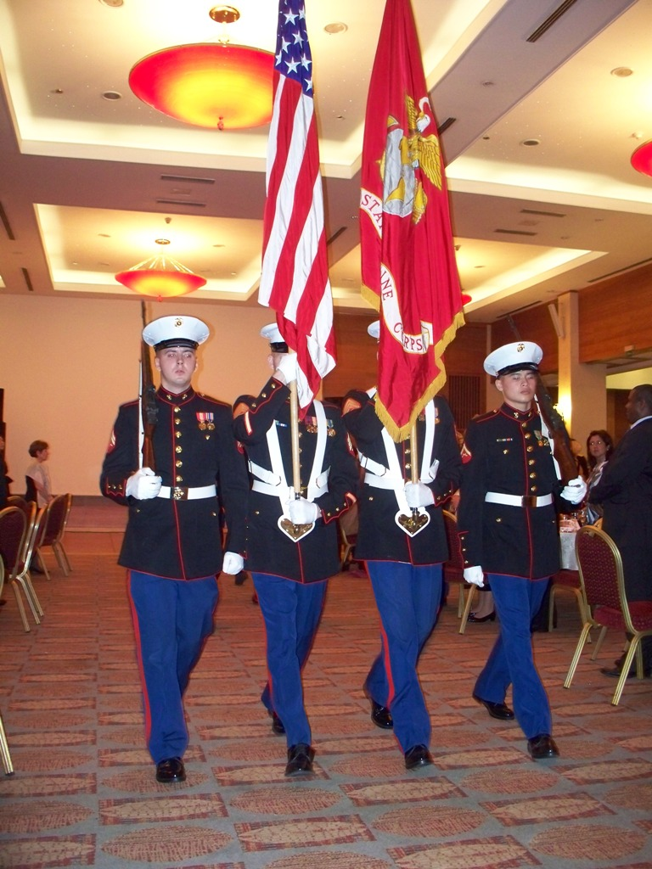
We attended the 236th Marine Ball on Friday night the 11th. It’s a gala event that takes place all over the world. The Ball in Addis Ababa, is suppose to be the third largest, so it was an honor to attend and be a part of the Marine Corps celebration. Our office sat at one table as is shown below. The group included my boss and his wife and the two Seabees and their wives. We got home about 1:30 Saturday morning. At one point in the ceremony, when the Star Spangled Banner played, the Marine flag was gently lowered, leaving the Stars & Stripes tall and erect, to allow it to take the position of honor.

Saturday afternoon, the monkeys returned. They did a fair bit of damage in our yard and the one next door. Michael, our gardener will be upset when he comes in Monday morning.
Monday, the 14th. : We are told our household goods will be here tomorrow. In the morning, we will go and watch the seal on the shipment removed and will check for any damage to our vehicle. It will still be a few more weeks before we have use of it, but the household items will be delivered right after the seal is broken.
Traveling through the city is always an interesting experience. I had intended to discuss the driving and roads here, but I’ll have to do that next time.
Later, #6, Dad, D, fred, OG … & Terese

