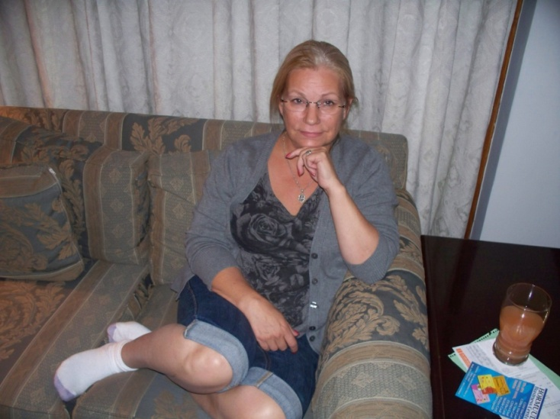
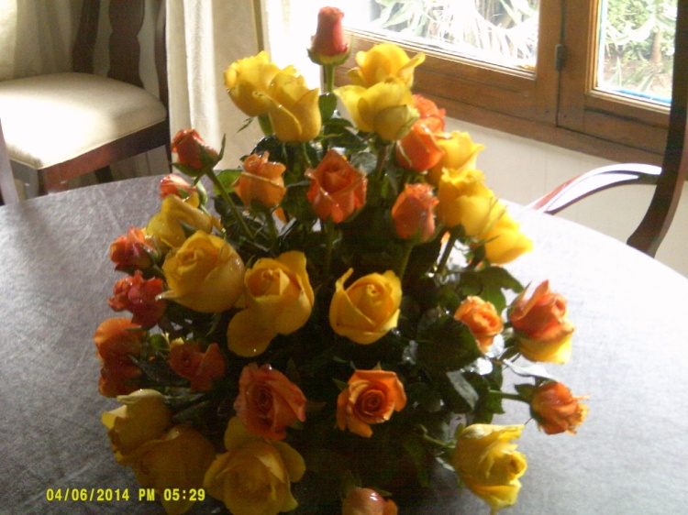
We arrived in Addis without any fanfare. No singing choirs or dancing poodles to welcome us (my apologies to my brother Gary), just a friendly embassy driver, our sponsor, my new boss and a beautiful bouquet of roses on the dining room table. Everyone has a sponsor appointed by the embassy to help newcomers get settled in. Ours is named, Jason. My boss, Steve, is someone who works hard giving 110% and expects others to do the same. He is a nice guy, but very serious. I will work on getting him to laugh. So, instead of taking off the following day after arrival, as is usually done, I went into the office the next morning. Started the check-in procedure with only half a brain functioning, which will last more than two weeks, (the check-in procedure).
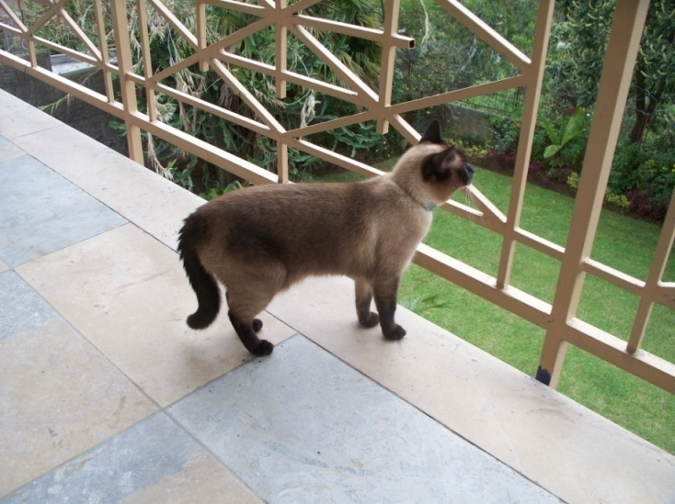
It took two flights to get here. One 7 hour and one 6 hour. Terese made the flights okay as I did. See picture. The crazy Siamese made the trip okay, too. She squalled only occasionally. Once here it became a new world to explore. After her arrest in Virginia for getting on the roof of the apartment complex, we have to watch her. If she gets out, she can disappear quickly and we will lose her. I would normally have mixed emotions about that, but considering all the money and undue stress we had to put up to get her here (notice the emphasis on stress), she better stay alive for awhile. We were sitting on our lower patio the other day and she was screaming at us because she could see us, but not join us. We ignored her and eventually she just turned her back to us. Below, she is watching the birds from the third floor. It’s a new world for her.
Our apartment is half of a duplex. We have four floors where the fourth floor is a room on the roof - a terrace. Small front and back yards. It will still be at least a week more before we can get the Internet set up in the apartment. Same with TV access. The previous tenant left us a satellite system he purchased and left for us, but someone in the embassy made off with it before we got here. So, no Internet or TV until late next week.
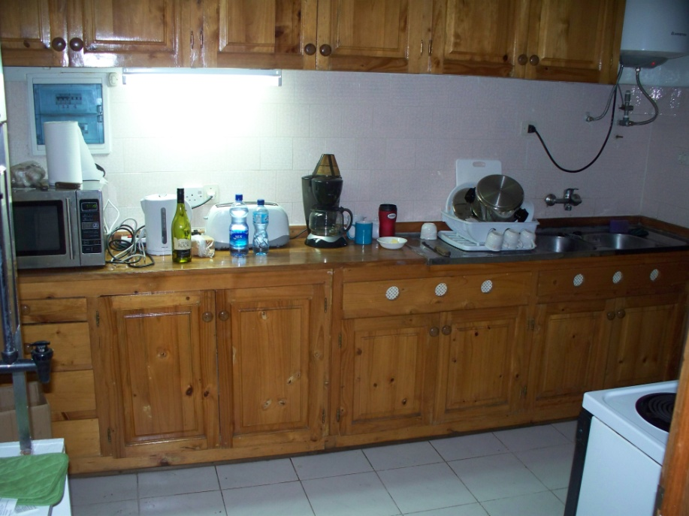
The apartment has at least 25 keys. Every exterior door has its own gate, and there is a key for each door and each gate. There are three bedrooms on the third floor which one will become an office. Two full baths on the same floor and a half bath on the lower floor. The property is on a slope, so the entrance to the apartment in the front is on the second floor and the backyard is accessed from the first floor. No garage but a carport. The lower floor is one large room with a big fireplace. There are light switches all over the place. Occasionally while trying to determine how to turn on a light, we would hear a bell ring. Took me longer than it did Terese, to figure out the switches with little raised circles on them are to call the servants, or guards. I kept wondering why the guard would show up at the door every now and then. I had Terese apply a small drop of her nail polish on them so I can see what switch not to use in the poor lighting of the house.
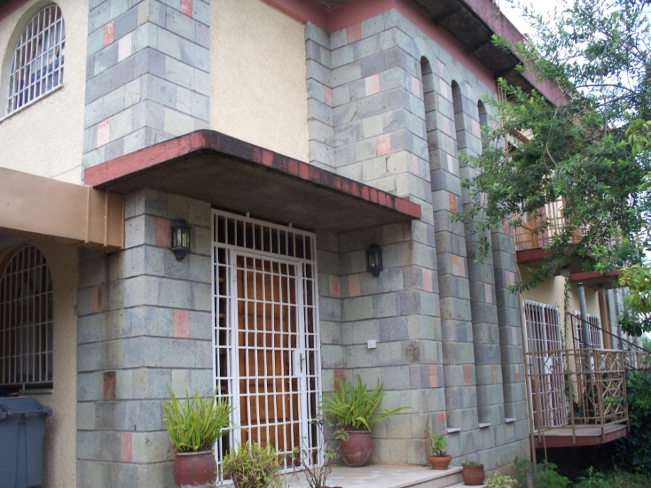
The kitchen is small and barren with a small counter and few cabinets that are mounted too high. Terese is not happy about that. There is a still in the kitchen that we get our potable water from. The city water is not for consumption. The dining room is a normal size. Same with the living room and a small front room near the foyer. The flooring is all parquet wood (the real stuff, not fake linoleum) with small carpets in the middle. Walls are solid plaster and some have tiles. I like this style of house with the arched doorways. The furniture is the same style found in most State Department housing. Expensive Ethan Allen. Not our choice of décor, but we have no say.
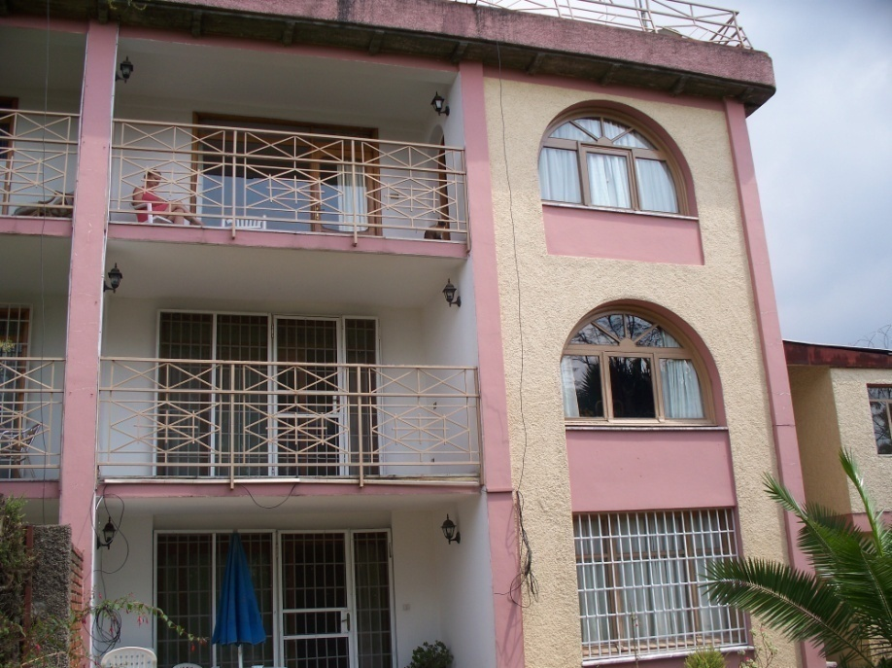
The outside of the apartment is rough block. Not an architectural masterpiece. The top terrace is just the rooftop shared with the other tenant of the duplex. A nice place to venture out to see the surrounding countryside, but not really a place to entertain, but each of the lower three floors has a balcony/patio. We have our patio set coming which we will place on our third floor balcony just outside our bedroom. The ground floor has a patio set already in the backyard. The yard is small and beautiful and very well kept by a day-guard who is also our gardener. The Embassy is very serious about our protection. We also have a night guard who is monitored by the Embassy. We always have a radio to contact Post One directly in case something is wrong. Post One is the nerve center of the Embassy manned by Marines. The duplex has Constantine wire, more commonly known as razorwire around the top of the perimeter walls. There is little violent crime here, but plenty of burglary and petty thievery. Our guards are good people. The night guard rotates with the neighbor’s guard. I will have to ask them again for their names and write them down.
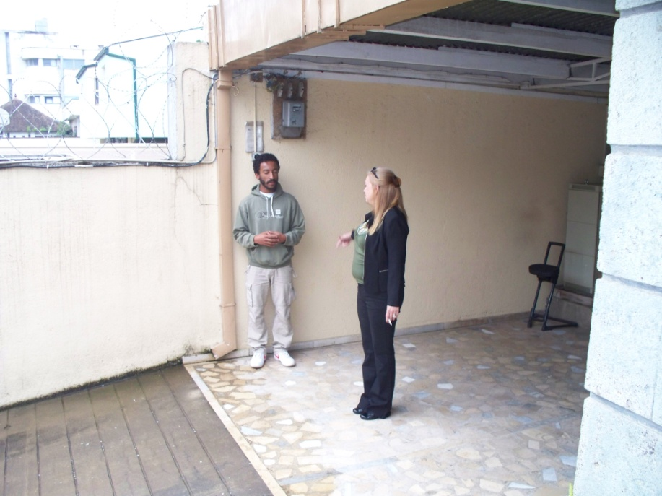
The day-guard/gardener is Michael, (pictured with Terese) who is attending University to become an Electrician. We found out yesterday, we were supposed to be supplying his lunch every day.
The apartment has several more exterior rooms. One for the gardener, one for the night guard, one for the guards to change their clothes, a small bathroom for them with a Turkish toilet, a room for the laundry, one for storage which includes a freezer. And several more that are empty, including one on the roof.
I have four locals who will be working under me. I will lose one who is going to be placed in Djibouti permanently. One of them is Solomon and one is Elias. Once I get the other’s names remembered, I will pass them on. All four of these men are very good at what they do. As with all locals we encounter, they are very friendly and always greet you with a smile and a nod. Our guards greet us with a salute.
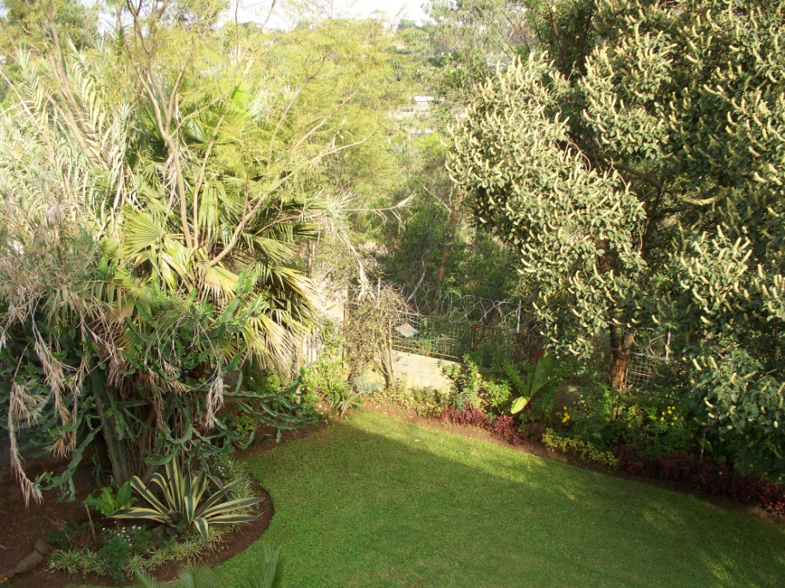
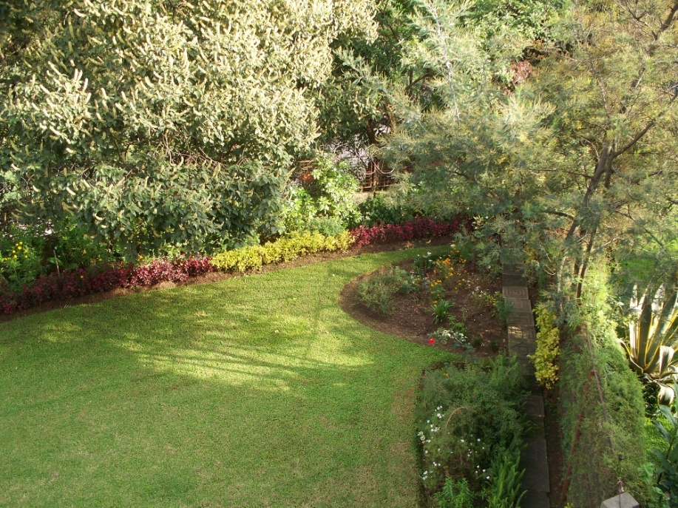
This is a picture of half of our backyard taken from the third floor balcony. Below is the other half. The streets are very busy with a great many pedestrians. Many waiting for rides. There are many beggars, especially in the streets (a few with cell phones). There is one old woman who sits on a pile of stones, begging. No one messes with her, as she throws the stones she sits on. It’s not uncommon to see herds of animals being guided through the streets. All part of daily life here. Traffic is crazy until about eight in the morning, then it becomes horrible. There are major intersections with traffic lights that only occasionally work. There is one intersection where 7 lanes of traffic come in to a “T”. Not 7 roads, but an intersection where each road has 7 lanes. The intersection itself is so large, it looks like a parking lot, and the traffic light seldom works. The lines on the road mean nothing. Once a direction of travel starts moving, no one wants to stop. The only way the other direction gets going, is to nose their way into the traffic forcing the moving direction to stop or swerve. Not a pretty picture. Lots of horn honking. My drive to the Embassy in the mornings goes through that intersection, and others. It will take about 15 minutes to get to work if I leave before 7:00.
Just as in Rwanda, there is the constant smell in the air of burning wood. It’s actually very mild, more of a fragrance and I find it very comforting. Perhaps I was an African Zulu in a previous life, or a monkey.
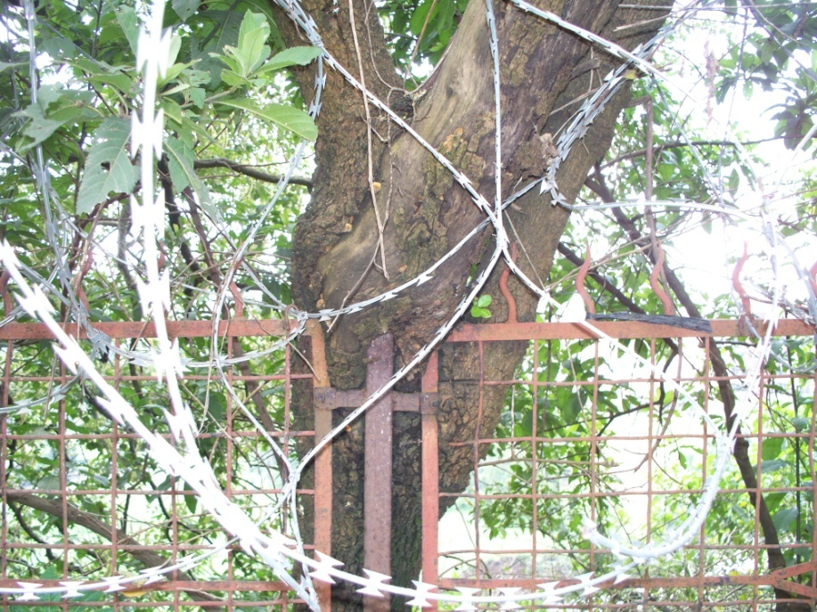
Speaking of monkeys, they are here. I haven’t seen them yet, but Terese has. There is a very small plot in the backyard where previous tenants have tried to grow a garden, and the monkeys harvested the produce before it’s time. It’s in the rainy season, so when we first arrived, I thought I kept hearing rain; but soon realized it’s the sound of a river. Beyond our backyard, there is a very deep cliff, over a hundred feet, where there is a raging river. The growth and trees do not give us a clear view of it, but we can see enough to know it’s a deep gorge. Our night guard says it’s runoff from the rains, and sewage. … nice …. sewage. When the dry season returns, it will become a trickle.
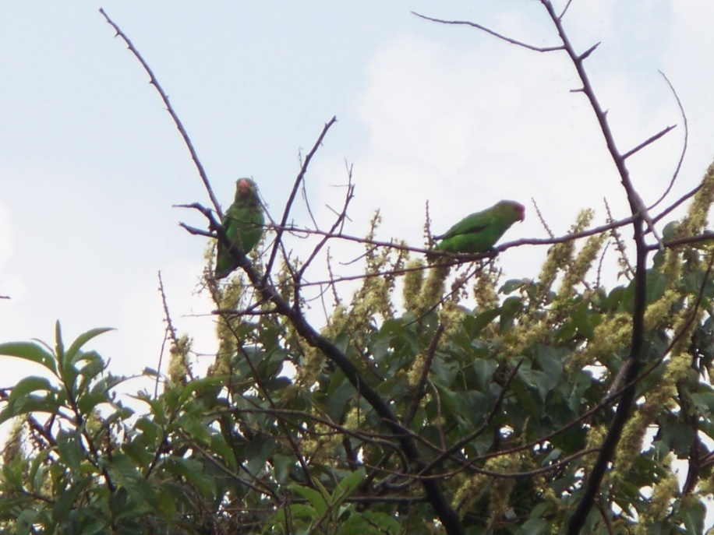
A tree has grown around the metal and concrete back wall. The cliff is so close, that the tree is holding up the wall. Or maybe the wall supporting the tree. Either way, the back of the yard is slowly dropping off the cliff. Hopefully, it will hold up at least another two years.
One of the many nice things about Africa is not just the plants, but the animals. I sat out on one of the balconies Saturday watching the birds and realized we have become my parents. Just like Mom & Pop at Ransom Canyon, we sit outside watching birds. We even have a pair of binoculars handy. Africa has birds as unique as the rest of its Animal Kingdom. We watched a couple of parrots sitting on one of our branches in the picture below. At first we thought they were parakeets, then Terese got the binoculars and saw they were indeed little parrots. Many birds have long curved beaks which I guess it either for digging seeds out of fruit or for getting insects. We see black birds like crows but with ugly heads like a vulture. (next page) There are birds with long white tails like scissor tails, but wave like long banners, and one we’ve seen that has a secondary tail dragged behind like a kite. When we get the Internet set up, we will be able to do some research. Next year we will purchase a higher quality camera and should be able to get some phenomenal images, as we travel the area.

With the high altitude here, about 8000 ft., I find myself out of breath climbing all the stairs we have. They say it takes several weeks to adjust to the altitude. As the plane came in for the landing, I was watching the altimeter on the video screens behind the seats. It being dark, I couldn’t see outside the plane, so I was surprised when the plane touched down at 7800 feet instead of the usual 100 feet or so. Also at this altitude, water boils at a lower temp, so the coffee we make is not as hot as we are used to. I can drink it without letting it cool down first.
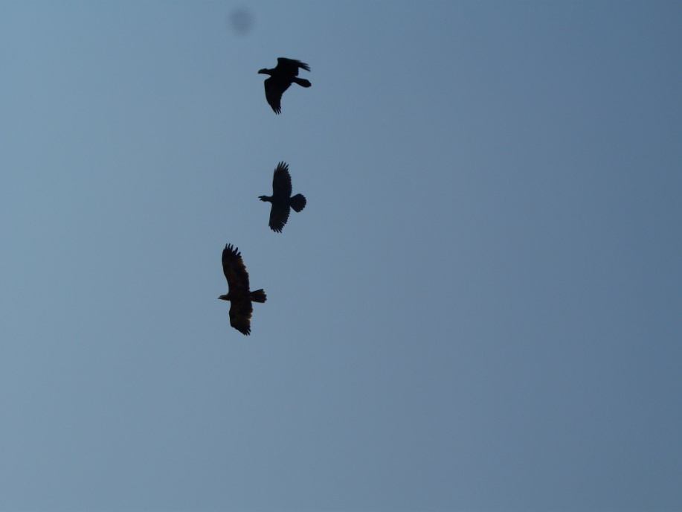
One of the things I knew we would have to endure is the Muslim call to prayer. This include nighttime. Since we are still trying to get over our jetlag, I wake up in the middle of the night and cannot go back to sleep. As I lay there, I hear the call to prayer, and it seems to last until dawn. Years ago, I would have thought it was something interesting. But now I find it eerie. I can do without it. Many centuries ago, when Mohammad had his visions with the Archangel Gabriel, the Lord instructed Mohammad that all muslins were to pray 100 times a day. The good and compassionate Mohammad graciously interceded for all muslins and was able to convince Allah to only require them to pray 5 times a day. Lucky for us. Five is bad enough. It will take some time to learn ignore it.
The infrastructure in Addis is like many cities in Africa. We lose our electrical power at least once a day, sometimes 3 or 4. Usually only lasts a few minutes. We have a generator that is suppose to kick in and keep us supplied, but it’s having battery problems. Hopefully it will be fixed this week.
The weather here is one of the more incredible aspects of Addis. We are on the tail end of the wet season. So far, every morning starts with sunshine, but by noon or later, it clouds up and the rain comes and goes throughout the day. Sometimes it’s just light rain and sometimes it has thunder and lightning. We are told, in a few more weeks the rains will stop as if someone turned off the valve, and then just abundant sunshine. Looking at the weather data for this area, it does get rain here throughout the year, but few and far between.
I have yet to grasp the concept of no real seasonal changes. The trees never have to drop leaves as far as I know. The grass will always be green and need to be trimmed. The daytime temps are always pleasant and the bird/animal life is unchanging.
Since being here, we’ve had no TV or Internet so we pretty much walk around the apartment bored, sitting occasionally on one of the many balconies to watch the birds or the rain. We make tea and coffee several times a day and eat cookies just for something to do. I was happy to find out that we would have an extra day (Labor Day) to sit around and recover, but now wish we didn’t.
Hence the long note. Love etc., etc, #6, dad, fred, D, OG & Terese, Mom

